**ASSIGNMENT 3**



**Fall 2022**

**Object Oriented Programming**

Submitted by: **Ali Asghar**

Registration No. : **21PWCSE2059**

Class Section: **C**

“On my honor, as student of University of Engineering and Technology, I have neither given nor received unauthorized assistance on this academic work.”

Submitted to:

**Dr. Nasruminallah**

January 20, 2023

Department of Computer Systems Engineering

University of Engineering and Technology, Peshawar

**QUESTION # 1:**

**CODE SCREENSHOTS:**

Here are the screenshots of the code.

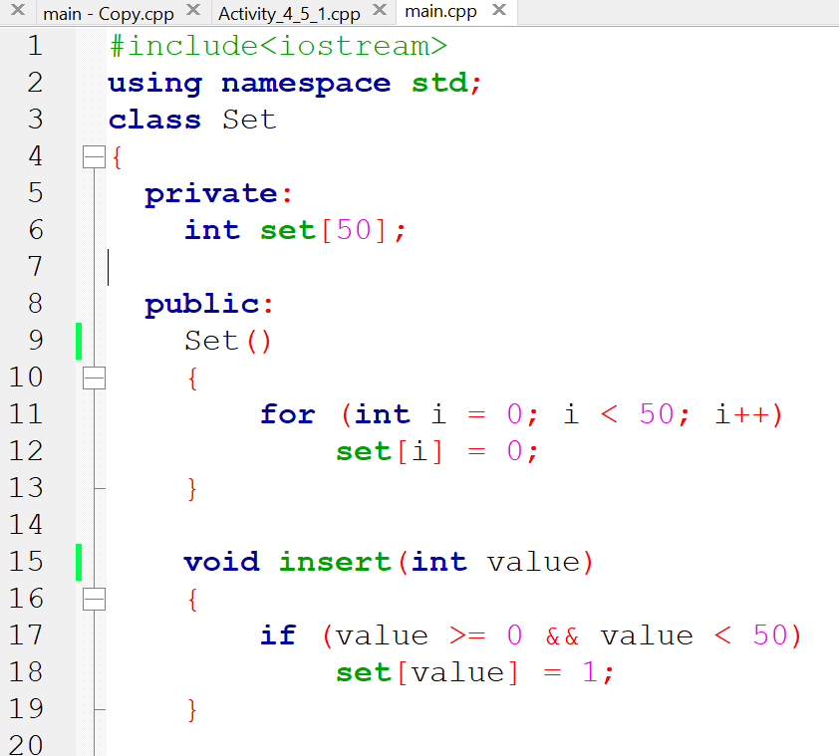

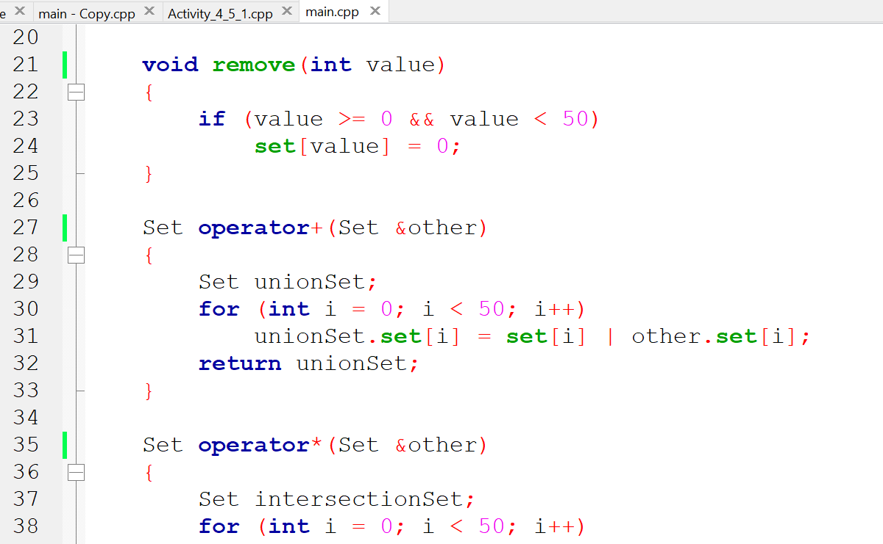

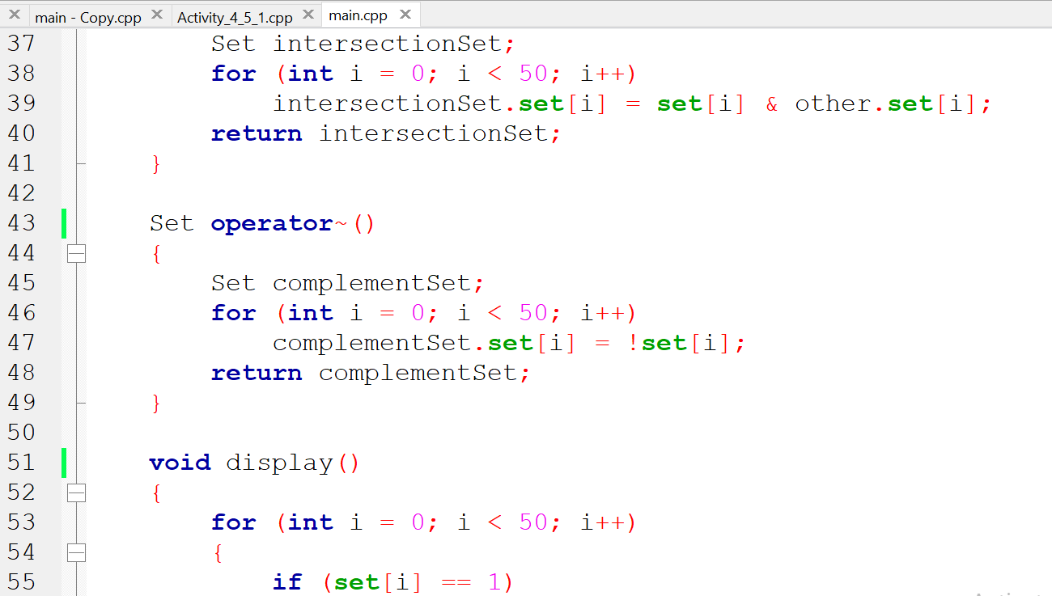

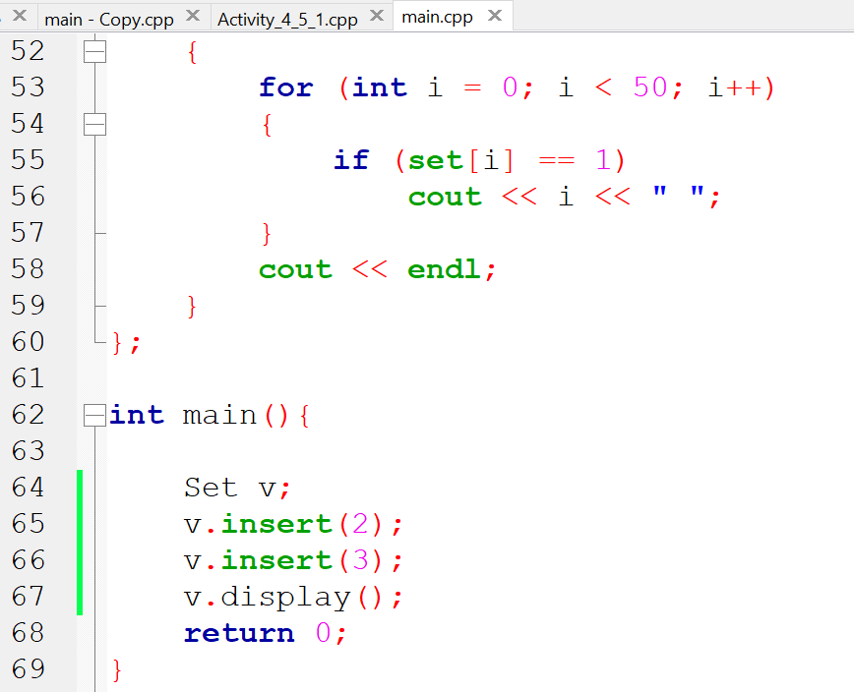

### **OUTPUT (COMPILATION, DEBUGGING & TESTING):**

Here is the screenshot of the output of above code.

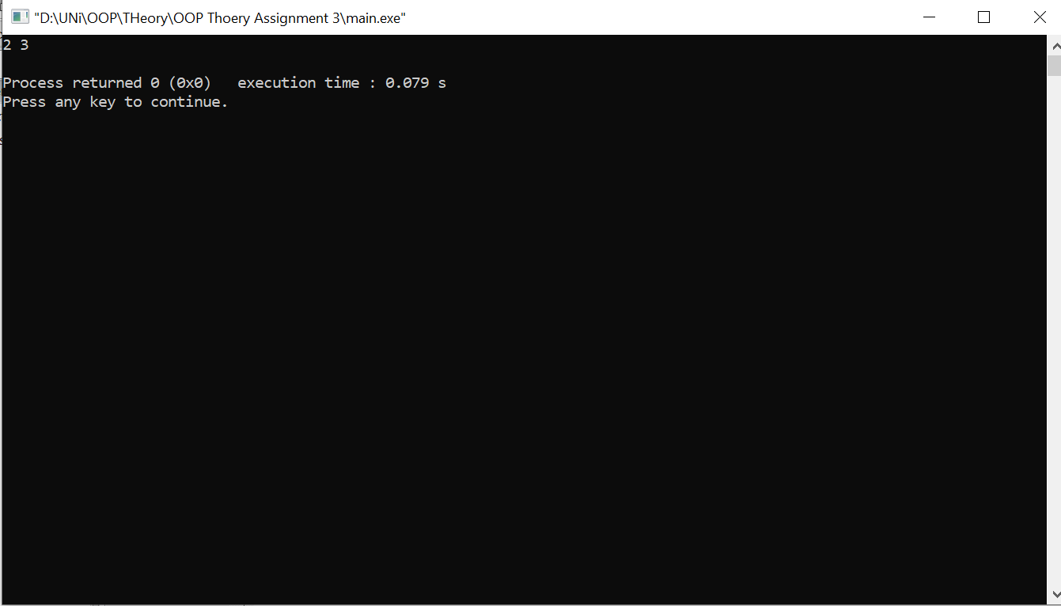

### **IMPLEMENTATION STRATEGY:**

The class has a private member variable called "set" which is an array of integers with a size of 50. The class has several member functions that allow for manipulating the set, including:

* The constructor: This function initializes all elements of the "set" array to 0.
* The "insert" function: This function takes an integer value as an input and sets the corresponding element of the "set" array to 1.
* The "remove" function: This function takes an integer value as an input and sets the corresponding element of the "set" array to 0.
* The "+" operator overload: This function takes another "Set" object as an input and returns a new "Set" object that contains all elements that are present in either of the two sets.
* The "*" operator overload: This function takes another "Set" object as an input and returns a new "Set" object that contains all elements that are present in both sets.
* The "~" operator overload: This function returns a new "Set" object that contains all elements that are not present in the original set.
* The "display" function: This function iterates through the "set" array and prints out all elements with a value of 1.

In the main function, an instance of the "Set" class is created and the "insert" function is called twice to add the values 2 and 3 to the set. The "display" function is then called to print out the contents of the set, which should be 2 and 3.